**CDAC Mumbai PG-DAC AUGUST 24**

**Assignment No- 2**

1)Write a program that checks if a given year is a leap year or not using both if-else and switch-case.

Code:

**package** org.in;

**import** java.util.Scanner;

**public** **class** leap {

**public** **static** **void** main(String[] args) {

Scanner scanner = **new** Scanner(System.***in***);

System.***out***.print("Enter a year: ");

**int** year = scanner.nextInt();

**boolean** isLeapYear = **false**;

**if** (year % 4 == 0) {

**if** (year % 100 == 0) {

**if** (year % 400 == 0) {

isLeapYear = **true**;

}

} **else** {

isLeapYear = **true**;

}

}

**if** (isLeapYear) {

System.***out***.println(year + " is a leap year.");

} **else** {

System.***out***.println(year + " is not a leap year.");

}

scanner.close();

}

}

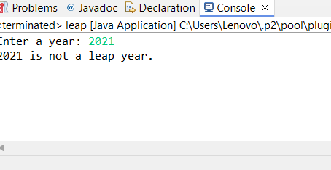

2)Implement a program that calculates the Body Mass Index (BMI) based on height and weight input using if-else to classify the BMI int categories (underweight, normal weight, overweight,etc).

CODE:

**package** org.in;

**import** java.util.Scanner;

**public** **class** BMI {

**public** **static** **void** main(String[]args) {

Scanner sc=**new** Scanner(System.***in***);

System.***out***.println("Enter the Height");

**float** Height=sc.nextFloat();

System.***out***.println("Enter the Weight");

**float** Weight=sc.nextFloat();

**double** bmi = Weight / (Height * Height);

System.***out***.printf("Your BMI is: %.2f%n", bmi);

**if** (bmi<18.5) {

System.***out***.println("UnderWeight");

} **else** **if** (bmi >=18.5 && bmi<25) {

System.***out***.println("Normal Weight");

}**else** **if** (bmi>=25 && bmi<30) {

System.***out***.println("o Overweight");

}**else** **if** (bmi>=30) {

System.***out***.println("Obese");

}

}

}

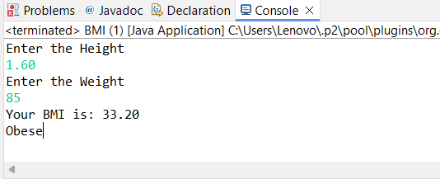

3)Write a program that checks if a person is eligible to vote based on their age.

Code:

**package** org.in;

**import** java.util.Scanner;

**public** **class** vote {

**public** **static** **void** main(String[] args) {

Scanner sc = **new** Scanner(System.***in***);

System.***out***.println("Enter the age");

**int** age = sc.nextInt();

**if** (age>=18) {

System.***out***.println("Eligible to vote");

}**else** {

System.***out***.println("Not eligible to vote");

}

}

}



4)Write a program that takes a month (1-12) and prints the corresponding season (Winter, Spring, Summer, Autumn) using a switch case

Code:

**package** org.in;

**import** java.util.Scanner;

**public** **class** season {

**public** **static** **void** main(String[] args) {

Scanner sc=**new** Scanner(System.***in***);

System.***out***.println("Enter the month");

**int** month=sc.nextInt();

String Seas;

**switch** (month) {

**case** 12:

**case** 1:

**case** 2:

Seas = "Winter";

**break**;

**case** 3:

**case** 4:

**case** 5:

Seas = "Summer";

**break**;

**case** 6:

**case** 7:

**case** 8:

Seas = "Rainr";

**break**;

**case** 9:

**case** 10:

**case** 11:

Seas = "Autumn";

**break**;

**default**:

Seas = "Invalid Input ";

**break**;

}

System.***out***.println("The sesason is "+Seas);

}

}

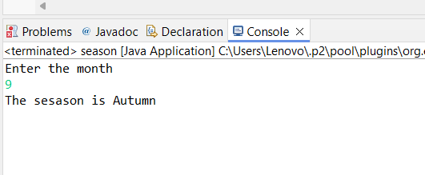

5)Write a program that allows the user to select a shape (Circle, Square, Rectangle, Triangle) and then calculates the area based on user-provided dimensions using a switch case.

Code:

**package** org.in;

**import** java.util.Scanner;

**public** **class** shape {

**public** **static** **void** main(String[] args) {

Object system;

Scanner sc = **new** Scanner(System.***in***);

// Display the shape options to the user

System.***out***.println("Select a shape to calculate the area:");

System.***out***.println("1. Circle");

System.***out***.println("2. Square");

System.***out***.println("3. Rectangle");

System.***out***.println("4. Triangle");

System.***out***.print("Enter your choice (1-4): ");

**int** choice = sc.nextInt();

**double** area = 0;

**switch** (choice) {

**case** 1:

System.***out***.print("Enter the radius of the circle: ");

**double** radius = sc.nextDouble();

area = Math.***PI*** * radius * radius;

**break**;

**case** 2:

System.***out***.print("Enter the side length of the square: ");

**double** side = sc.nextDouble();

area = side * side;

**break**;

**case** 3:

System.***out***.print("Enter the length of the rectangle: ");

**double** length = sc.nextDouble();

System.***out***.print("Enter the width of the rectangle: ");

**double** width = sc.nextDouble();

area = length * width;

**break**;

**case** 4:

System.***out***.print("Enter the base of the triangle: ");

**double** base = sc.nextDouble();

System.***out***.print("Enter the height of the triangle: ");

**double** height = sc.nextDouble();

area = 0.5 * base * height;

**break**;

**default**:

System.***out***.println("Invalid choice");

**break**;

}

**if** (choice >= 1 && choice <= 4) {

System.***out***.printf("The area of the selected shape is: %.2f%n", area);

}

sc.close();

}

}

